Дата: 14.05.2025

Клас: 7-АБ

Предмет: англійська мова

Тема: Контрольна робота №8 за темою «Sports».

Мета: : формувати навички вживання лексичних одиниць по темі; удосконалювати навички читання, аудіювання й усного монологічного мовлення; розвивати пізнавальні інтереси учнів; виховувати інтерес до самостійного пошуку потрібної інформації, а також загальну культуру учнів.

Вчитель: Руда Д.В.

Хід уроку

1.Greeting

Good afternoon, guys! I’m tickled pink to see you. Are you ready to start our lesson? All set?

Let`s get down to business.

2. Wаrm up / Listening

Уважно слухати аудіо трек і дати відповідь на питання вчителя <https://www.youtube.com/watch?v=m71IA27AbAo> .

3. Повторення

*Sleet-мокрий сніг(сліт)*

*Snowflake-сніжинка(сноуфлейк)*

*Blizzard-хуртелиця (блізард)*

*Mild: moderate in temperature; neither hot nor cold- помірний, м’який (майлд)*

*"Every cloud has a silver lining": every bad situation has some positive aspect to it. (e.g., "I lost my job, but I found a better one soon after. Every cloud has a silver lining.")- нема лиха без добра( ідіома)*

*Chilly-прохолодний(чілі)*

*To get cold-холоднішати*

*It`s raining cats and dogs-сильно дощити (ідіома)*

*precipitation-опади (прісіпітейшн)*

*partly cloudy- мінлива хмарність (патлі клауді)*

.

*To pollute-забруднювати*

*To recycle-переробляти*

*A leaflet-листівка*

*To predict-передбачати*

*A recycling bin-контейнер для сміття*

*To prevent- запобігати*

4. Speaking

Why do you study English?

Do you enjoy speaking in a language that is not your mother tongue?

How well do you speak English?

What level of English would satisfy you? What learning goals do you have? Is it possible to learn to speak English like a native speaker does?

How did you feel about the English language education you received at school? How was it taught?

Is English easier or more difficult to learn than other languages? Why do you think so?

Do you speak any languages other than your first language and English? What do you like about those other languages?

When it comes to English, what are your strengths and weaknesses? Choose from vocabulary, grammar, fluency, pronunciation, reading, listening, writing, and knowledge of idioms. Which do you most want to improve?

Have you taken any standardized English tests such as TOEIC, TOEFL, or IELTS? Did studying for these tests help you to improve your English?

English is widely spoken as a second language around the world. Why is this?

5. Writing

**Sports from A to Z**

**Test Form 7**

1. **Translate the words.**

**a) into Ukrainian**

1. a flame 7. to win

2. fencing 8. to compete

3. figure skating 9. to take place

4. cycling 10. to cheer up

5. score 11. outdoor sports

6. membership 12. a team game

**b) into English**

1. команда 7. брати участь

2. спортивна подія 8. представляти

3. найкращі спортсмени 9. перемагати

4. змагання 10. бігати

5. футбольний матч 11. олімпійський вогонь

6. зимові види спорту 12. тренування

1. **Group up the sports into 3 columns.**

Judo, golf, water polo, snowboarding, handball, fencing, wrestling, athletics, high jump, boxing, soccer, karate

|  |  |  |
| --- | --- | --- |
| Play | Go | Do |
|  |  |  |

**3. Put the sentences into reported speech.**

Put the sentences into reported speech.  
1. Peter asked me, "Did you go to the cinema yesterday?"  
Peter asked me .  
2. She asked me, "Have you ever been in Spain?"  
She asked me .  
3. They were ordered, "Don't be unfriendly!"  
They were ordered .  
4. Eve asked him, "What can I do for you?"  
Eve asked him .  
5. He asked her, "Do you know the right way?"  
He asked her .

6. The newspaper reported, "There will be a change in government next week."  
The newspaper reported that  a change in government .

7. Linda told us, "I have been working here for the past three years.  
Linda told us that  for the past three years.

8. The boy said, "I'll be back by 11."  
The boy said that  by 11.

9. The teacher told Mrs Smith, "Your son is improving".  
The teacher told Mrs Smith that  .

**4. Answer the questions.**

1. Why is sport useful for people?

2. Which are the most popular sports in Ukraine?

3. Do you do any sports? What sport is it?

4. What sports games do you play on PE lessons?

5. Do you take part in any competitions?

4. Who is your favourite sportsman?

6. Vocabulary

*Fatigue – виснаження (фетіг)*

*Diarrhea- діарея (дайріе)*

*bite -укус*

*bleeding -кровотеча*

*bleed кровоточити*

*burn-спекти, опік*

*choking-задуха*

*choke-задушити*

*fracture-перелом*

*heart -серце*

*attack-напад*

*illness-хвороба*

*To destroy-руйнувати*

*To increase - збільшувати*

7. Homework

1. Виконати письмово вправу 1 подану нижче.

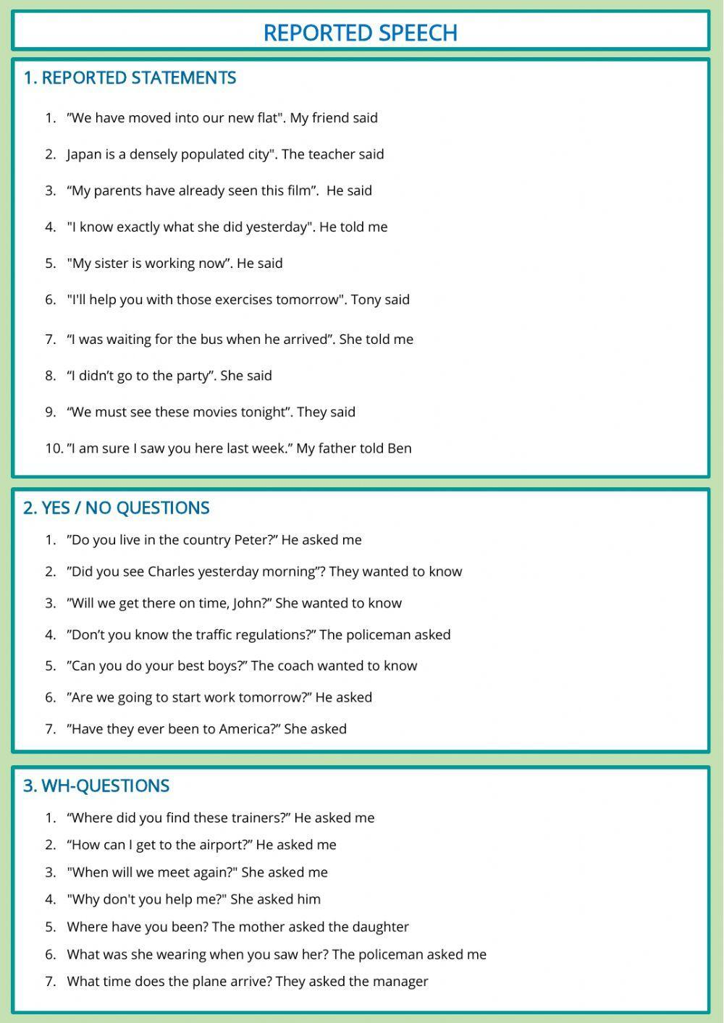

2. Повторити слова в словнику.